1. Project Charter

1.1. Project Overview

The Online Quiz & Assessment Portal is a web-based system designed to enhance the efficiency of academic assessments. It enables teachers to create and manage quizzes digitally, allows students to attempt them online, and provides automatic grading with instant results. An AI-based module generates quiz questions from uploaded study materials.
The system reduces manual effort, improves accuracy, and supports digital transformation in education.

1.2. Project Objectives

- Enable teachers to create, manage, and publish quizzes through an intuitive digital interface.
- Allow students to attempt quizzes online and receive instant, automated results.
- Implement an AI-powered module that generates quiz questions from uploaded text or topic notes.
- Provide a results dashboard with basic analytics for performance tracking.
- Deliver a working, tested prototype within the semester timeline.

1.3. Project Scope

In Scope:
- Authentication
- Quiz management
- Student interface
- Auto-grading
- AI question generation
- Dashboard

Out of Scope:
- Advanced analytics
- Mobile app
- Full deployment
- Plagiarism detection

1.4. Stakeholders

Stakeholder Group | Role | Key Responsibilities
Project Team (SPM & SRE) | Development Team | System design, development, testing, documentation
Teachers | Primary Users | Create, manage, and review quizzes
Students | Primary Users | Attempt quizzes and view results
Instructor/Supervisor | Project Authority | Guidance, evaluation, approvals
University | Oversight Body | Academic supervision and support

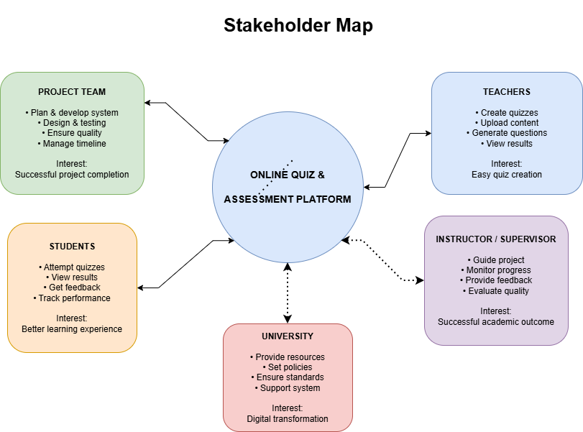

1.5. Project Milestones

SPM Phase | Duration | Major Deliverables | Activities
Initiation & Planning | Week 1 | Charter, Requirements, Plans | Stakeholders, scope, WBS, schedule, risk & quality plans
Execution | Week 2 | Working Modules | Development of quiz system, student interface, auto-grading, AI integration
Monitoring & Controlling | Week 2–3 | Tested System | Tracking, bug fixing, performance improvements
Closing | Week 3.5 | Final Prototype | Testing, documentation, final demo

1.6. Assumptions

- All team members have foundational knowledge of the selected tech stack.
- Free-tier tools and APIs will be sufficient for prototype delivery.
- The AI question generator will use an available NLP API.
- The supervisor will be available for weekly reviews and approvals.
- Internet access and development hardware are available to all team members.

1.7. Constraints

- Development timeline is fixed at 3.5 weeks with no extension.
- Budget is limited to free or low-cost academic tools and services.
- Team size is fixed at 5 members with no additions.
- AI API accuracy is dependent on third-party model performance.
- Academic scope

1.8. Risks

Risk | Likelihood | Impact | Mitigation Strategy
Inaccurate AI questions | Medium | Medium | Manual review/editing
Performance issues | Medium | High | Backend optimization, scalable services
Security vulnerabilities | Low | High | Secure authentication, encryption
Team delays | Medium | Medium | Task tracking and distribution
API cost overuse | Low | Low | Monitor usage, use free tiers

1.9. Success Criteria

The project will be considered successful when the following outcomes are achieved:

- Teachers can create, manage, and publish quizzes through the platform without technical difficulty.
- Students are able to attempt quizzes online and receive instant, automated results upon submission.
- The AI module is able to generate relevant and usable questions from uploaded topic content.
- The system is able to handle concurrent access by multiple users without performance failure.
The team is able to deliver all integrated modules and submit the project within the 3.5-week deadline.
2. Initiation
2.1. Scope
The AI-Powered Quiz System is designed to simplify the quiz creation and evaluation process for teachers and students. The system allows teachers to create quizzes manually or generate quiz questions automatically using AI from uploaded topic text or study material. Students can attempt quizzes online, and the system automatically grades objective questions and displays results instantly.
The main scope of the system includes:
- Teacher registration and login
- Student registration and login
- Manual quiz creation by teachers
- AI-based quiz generation from uploaded text/topics
- Quiz assignment to students
- Online quiz attempting by students
- Automatic grading of quizzes
- Result generation and display
- Basic performance tracking for teachers
This system focuses on improving efficiency in assessment management and reducing teachers’ workload in quiz preparation and grading.

2.2. Constraints
The development and implementation of the AI-Powered Quiz System may face the following constraints:
Technical Constraints
- AI-generated questions depend on the quality and clarity of uploaded text.
- Internet connection is required for accessing the platform.
- Limited AI accuracy in generating highly complex or subjective questions.
Resource Constraints
- Limited development time within the academic project schedule.
- Limited budget for advanced AI tools or paid APIs.
- Development may rely on free or open-source technologies.
Operational Constraints
Teachers and students require basic digital literacy to use the system.
System performance may slow with large numbers of users.

2.3. Assumptions
The project is developed based on the following assumptions:
- Teachers and students will have access to internet-enabled devices.
- Users will provide valid login credentials.
- Teachers will upload relevant and understandable topic content for AI quiz generation.
- Students will attempt quizzes honestly within the system.
- The institution has the basic infrastructure to deploy and use the system.
- The number of users during initial deployment will remain manageable.

